PROJECT DOCUMENTATION
Metro Ticket Generating System in ServiceNow

1. INTRODUCTION
This document describes the Metro Ticket Generating System developed using the ServiceNow platform. The format is adapted from the provided Full Stack Development with MERN project documentation format. Since this project is implemented in ServiceNow and not MERN, the MERN-specific technologies such as React, Node.js, Express.js and MongoDB are not used.
• Project Title
Metro Ticket Generating System in ServiceNow
• Team Members
Individual Project
2. PROJECT OVERVIEW
• Purpose
The purpose of the project is to provide a simple digital metro-ticket booking process through the ServiceNow Service Portal. The system allows passengers to select their journey details, calculate the fare automatically, select a payment mode, submit the booking and generate a digital QR ticket.
• Features
- Book a metro ticket through the ServiceNow Service Portal.
- Select Starting From and Going To metro stations.
- Select Single Journey or Return Journey.
- Select the number of passengers.
- Automatically calculate the fare based on route, journey type and passenger count.
- Select payment mode: UPI, CARD or Others.
- Validate required booking information.
- Submit the metro ticket request.
- Generate and display a digital QR ticket.
3. ARCHITECTURE
• Frontend
The project does not use React. The user interface is implemented using the ServiceNow Service Portal and the Service Catalog. The main catalog item is “Book A Metro Ticket”, where passengers enter and select their booking details.
• Backend
The project does not use Node.js or Express.js. ServiceNow provides the application platform, server-side processing and database-backed application functionality. Catalog Client Scripts using JavaScript handle client-side validation and fare-calculation behavior.
• Database
The project does not use MongoDB. Data is stored using ServiceNow platform tables. A custom Metro Station Detail table, u_metro_station_detail, is used for metro station information. ServiceNow records are used to maintain the ticket/request information.
Layer | Project Component | Purpose
User Layer | ServiceNow Service Portal | Passenger interacts with the booking form.
Application Layer | Service Catalog – Book A Metro Ticket | Collects ticket-booking information.
Logic Layer | Catalog Client Scripts / JavaScript | Validation and automatic fare calculation.
Data Layer | ServiceNow Tables | Stores station and booking information.
QR Layer | QR Code Generation Service | Generates the digital QR code for the ticket.
4. SETUP INSTRUCTIONS
• Prerequisites
- Access to a ServiceNow development/instance environment.
- A user account with permission to create and configure Service Catalog components.
- A modern web browser.
- Access to the ServiceNow Service Portal.
- Configured Metro Station Detail table and station records.
• Installation / Configuration
1. Log in to the ServiceNow development instance.
2. Create or open the Metro Ticket Generating System application/configuration.
3. Create/configure the Metro Station Detail table (u_metro_station_detail).
4. Add metro station records and configure the station name as the display value.
5. Create the “Book A Metro Ticket” Service Catalog item.
6. Create the required variables for source, destination, journey type, passengers, fare, payment mode and related fields.
7. Configure Question Choices for journey type, passenger count and payment mode.
8. Configure Catalog Client Scripts for validation and automatic fare calculation.
9. Configure the QR-ticket generation flow/widget used by the project.
10. Open the Service Portal and test the complete booking flow.
5. FOLDER STRUCTURE
A conventional client/server folder structure is not used because this is a ServiceNow platform project rather than a MERN application.
• ServiceNow Project Structure
- Application / Project configuration
- Service Catalog
- Catalog Item – Book A Metro Ticket
- Catalog Variables
- Question Choices
- Catalog Client Scripts
- Metro Station Detail table – u_metro_station_detail
- Service Portal / Catalog UI
- QR Ticket Widget / QR generation configuration
6. RUNNING THE APPLICATION
No npm start command is required because the project does not run as a local MERN application. The application runs inside the ServiceNow instance.
1. Log in to the ServiceNow instance.
2. Open the ServiceNow Service Portal.
3. Navigate to the catalog/service area.
4. Open “Book A Metro Ticket”.
5. Enter the journey details and submit the booking.
6. Verify the ticket and QR-code output.
7. API DOCUMENTATION
A Node.js/Express REST API backend is not used in the current implementation. Therefore, MERN-style backend endpoints are not applicable.
API Area | Status | Project Implementation
Node.js / Express endpoints | N/A | No separate Express backend is used.
ServiceNow Catalog processing | Used | Handled through ServiceNow platform configuration and scripts.
QR generation request | Used | QR generation service/API is used by the QR-ticket flow.
8. AUTHENTICATION
The project does not implement JWT or custom session authentication through a Node.js backend. Access to the application is controlled through the ServiceNow platform and its user/role-based access mechanisms. The exact authentication configuration depends on the ServiceNow instance.
9. USER INTERFACE
The user interface is the ServiceNow Service Portal booking experience. The main interface contains the following fields:
- Starting From
- Going To
- Type of Journey
- No of Passengers
- Amount for Single Journey
- Amount Including Return
- Mode of Payment
Recommended screenshots to insert:
- Book A Metro Ticket catalog item.
- Metro station selection.
- Journey type and passenger selection.
- Automatically calculated fare.
- Payment mode selection.
- Generated digital QR ticket.
10. TESTING
Testing focuses on functional behavior and application performance because the project is a ServiceNow rule-based application and does not contain a machine-learning model.
- Station selection validation
- Journey type validation
- Passenger count validation
- Automatic fare calculation
- Ticket submission
- QR ticket generation
- Form response time
- QR generation response
11. SCREENSHOTS OR DEMO
Insert the final ServiceNow project screenshots in this section. A demo link can also be added if a shareable ServiceNow project/demo URL is available.
- Screenshot 1 – Service Portal home / catalog.
- Screenshot 2 – Book A Metro Ticket form.
- Screenshot 3 – Selected route and journey details.
- Screenshot 4 – Automatic fare calculation.
- Screenshot 5 – Payment mode.
- Screenshot 6 – Digital QR ticket.
Results:
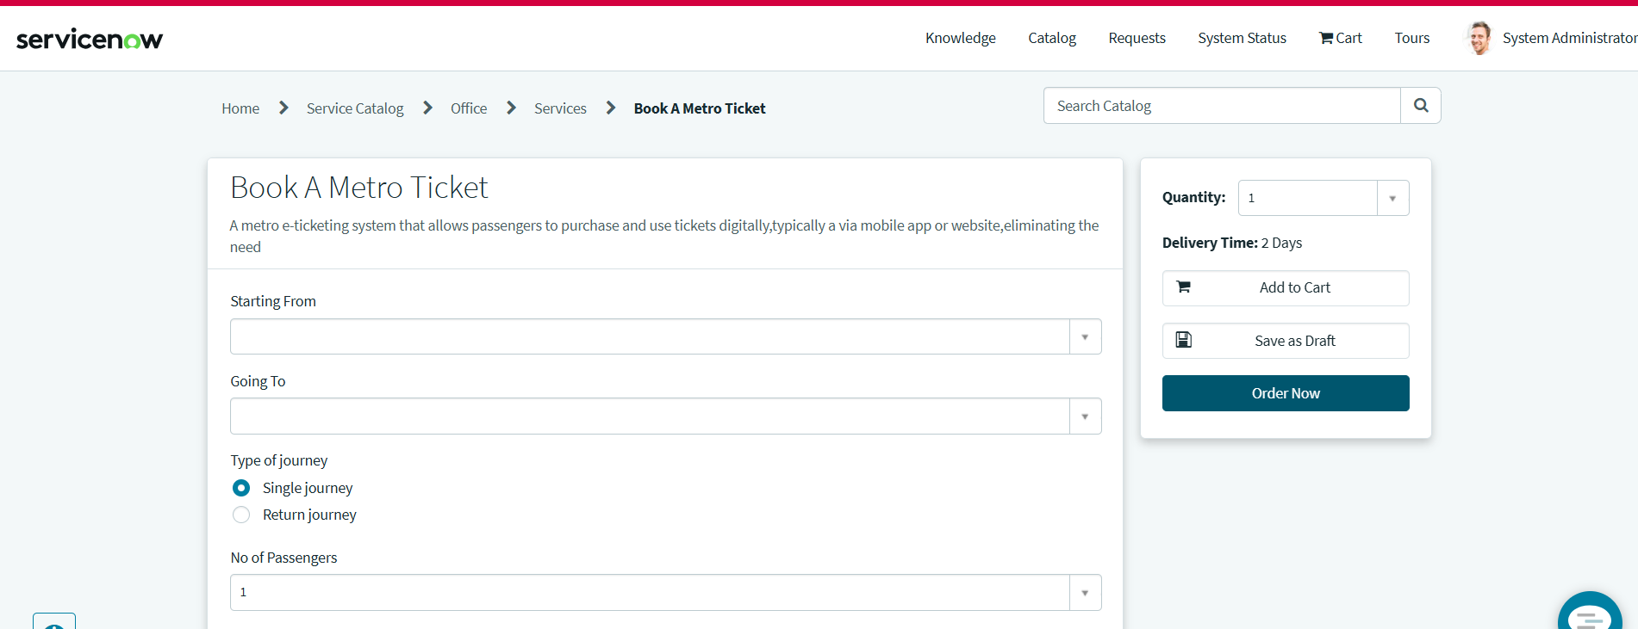

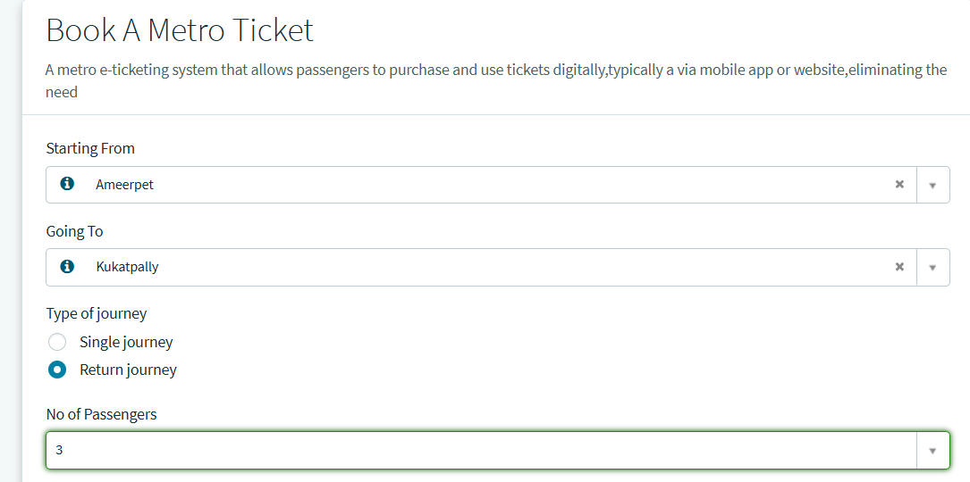

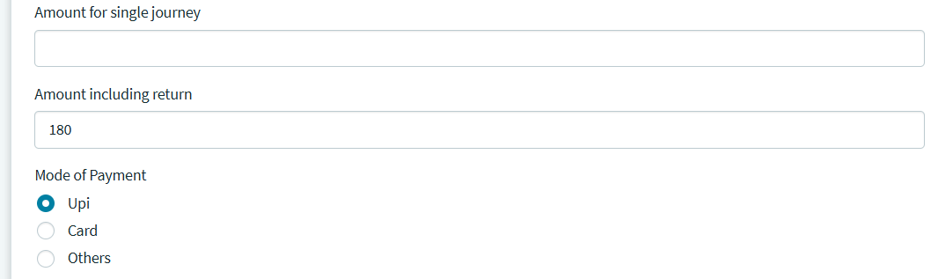
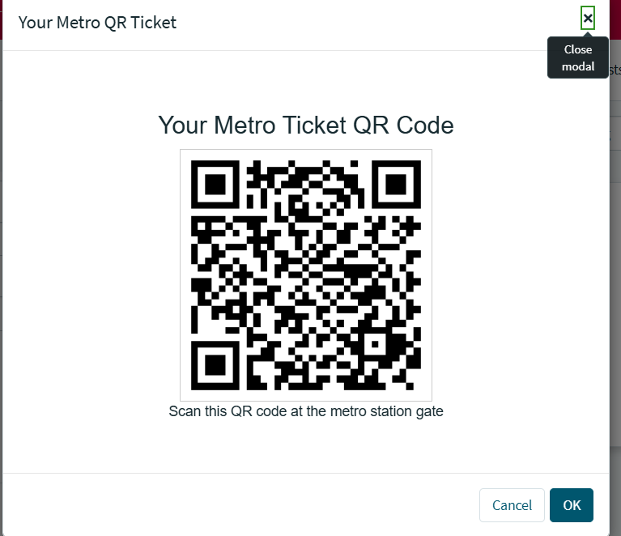
12. KNOWN ISSUES
- The current implementation supports only the stations and routes configured in the Metro Station Detail data and fare logic.
- The current project does not define a real payment-gateway transaction; payment mode is selected through the form.
- QR generation depends on the configured QR-code generation service.
13. FUTURE ENHANCEMENTS
Add more metro stations and dynamic route/fare management.
- Add ticket history and booking management.
- Add ticket cancellation and refund functionality.
- Add live metro train status and service alerts.
- Add email/SMS notifications.
- Improve QR validation at metro entry points.

